Gene Expression Analysis of Major Depressive Disorder (MDD) Using GEO Dataset GSE98793
Student: Narain Sarathy Jawahar
StudentID: 100223825
Course: Bioinformatics

1. Abstract
Major Depressive Disorder (MDD) is a complex psychiatric illness with limited biological markers. This project analyzes whole-blood microarray data from GEO dataset GSE98793 to evaluate whether gene expression patterns can distinguish MDD patients from healthy controls. After preprocessing and filtering to the top 10,000 most variable probes, exploratory analyses (PCA, UMAP, correlation heatmaps, and variable-gene heatmaps) showed substantial overlap between diagnostic groups. Differential expression analysis using Welch’s t-test identified no significant genes after FDR correction, with small fold changes across all probes. Logistic Regression achieved an AUC of 0.53, while Random Forest performed slightly better with an AUC of 0.63 and high recall for MDD but poor recall for controls. These results suggest that whole-blood expression profiles in this dataset do not provide strong discriminatory power for MDD classification. Larger sample sizes, batch correction, or multi-omics approaches may be required to detect meaningful molecular signatures.

2. Introduction
Major Depressive Disorder (MDD) affects mood, cognition, and functioning. Molecular signatures of MDD remain difficult to identify, particularly from blood-based transcriptomic profiles. Gene expression analysis allows exploration of disease-associated transcriptional changes, but prior studies indicate that psychiatric disorders often show subtle and heterogeneous expression differences.
GSE98793 is a publicly available microarray dataset profiling whole-blood expression in MDD and control subjects. This project aims to (1) preprocess this dataset, (2) assess global transcriptional patterns, (3) identify differentially expressed genes, and (4) evaluate machine learning models for diagnostic prediction.

3. Data

Dataset
- Source: NCBI GEO
- Accession: GSE98793
- Platform: Affymetrix U133 Plus 2.0
- Samples: 128 MDD, 64 Control
- Features: ~54,000 probes

Preprocessing Summary
- Download via GEOparse
- Extract phenotype + expression matrices
- Align sample IDs
- Log-transform values
- Filter to top 10,000 most variable probes
- Encode label: 1 = MDD, 0 = Control
4. Methods

Workflow
- Download dataset using GEOparse
- Clean and align metadata
- Filter probes by variance
- Perform PCA, UMAP, correlation heatmaps
- Conduct Welch’s t-test per probe + FDR
- Machine learning (train/test 70/30): Logistic Regression (scaled), Random Forest
Evaluation Metrics

Accuracy | Precision, Recall, F1 | ROC-AUC | Confusion Metrics
Tools
Python, Pandas, NumPy, Scikit-learn, Seaborn, Matplotlib, UMAP-learn, Google Colab.

GitHub Repository
https://github.com/Narain5/mdd-gene-expression-gse98793
5. Results

5.1 Exploratory Analysis
PCA: MDD and control samples overlapped substantially, showing no cluster separation.Correlation Heatmap: High similarity across all samples (0.80–0.97) with no diagnostic grouping.Top-50 Gene Heatmap: High inter-individual variability; no MDD-specific pattern.UMAP: Mixed clusters with no separation, consistent with PCA.

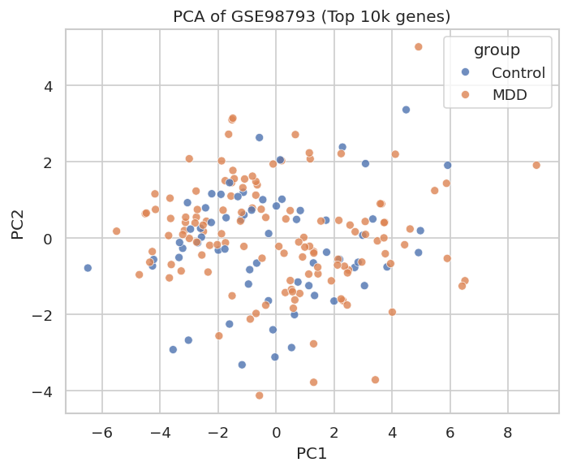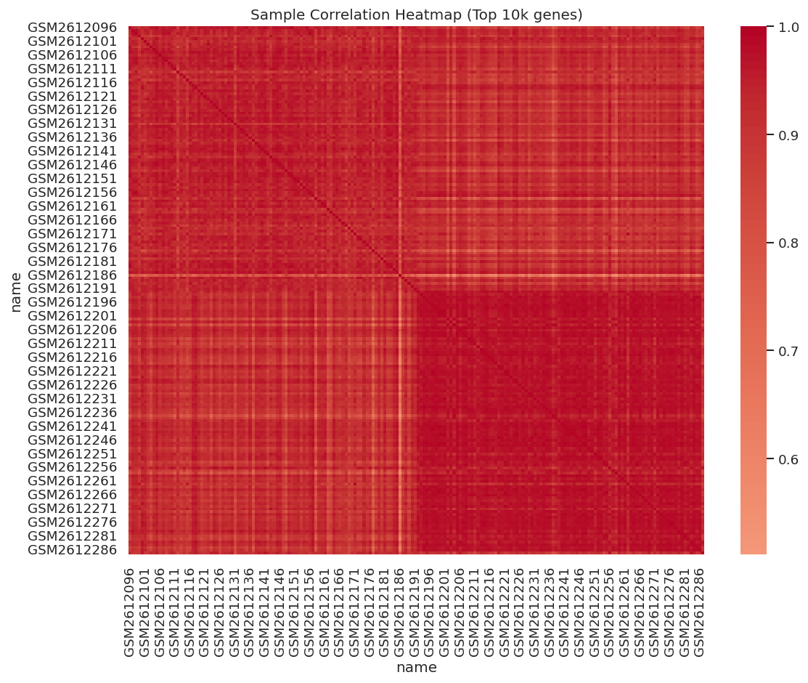
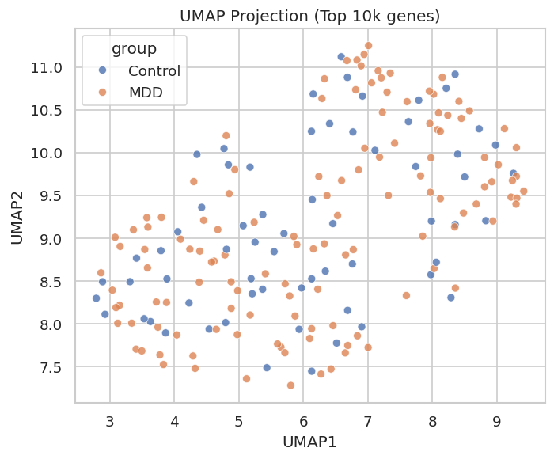
5.2 Differential Expression
Welch’s t-test across 10,000 probes found no significant genes after FDR < 0.05.Example probes:
Probe | P Value | Log2FC | FDR
224501_at | 0.043 | 0.094 | 0.865
224125_ar | 0.085 | 0.095 | 0.855
Fold changes were small (<0.12), indicating weak disease-associated transcriptional shifts.
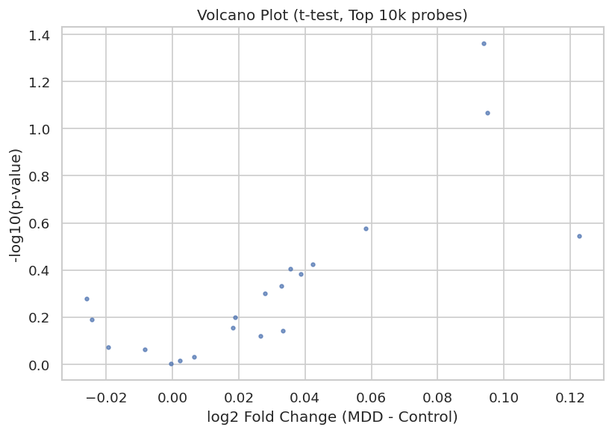
5.3 Machine Learning
Logistic Regression

Accuracy | AUC | MDD Recall | Control Recall
0.62 | 0.53 | 0.77 | 0.32
Random Forest

Accuracy | AUC | MDD Recall | Control Recall
0.62 | 0.63 | 0.90 | 0..05
Random Forest detected MDD moderately well but misclassified most controls, indicating imbalance and weak predictive signal.
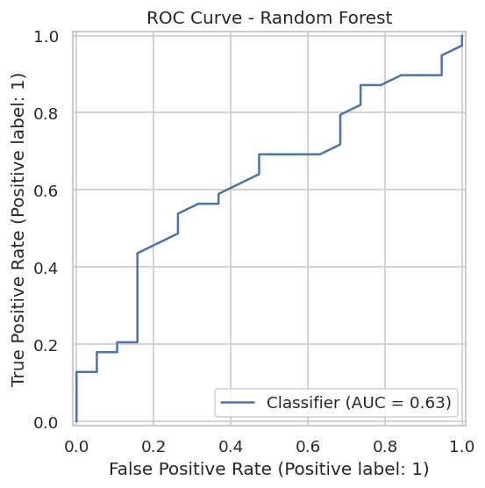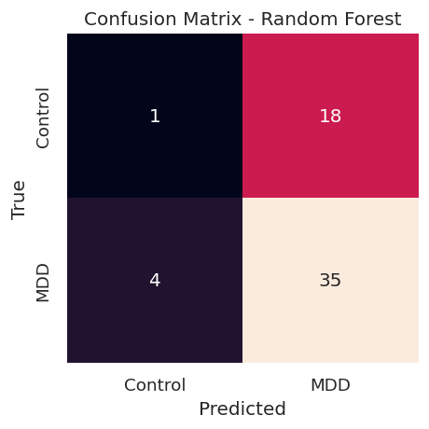

6. Discussion
All analyses show that whole-blood gene expression in GSE98793 does not clearly separate MDD from controls. PCA, UMAP, and heatmaps reveal overlapping profiles, and differential expression detects no significant genes with only small effect sizes. Machine learning models perform close to random, with Random Forest (AUC 0.63) still biased toward predicting MDD. These results align with existing literature showing that peripheral blood captures only subtle, distributed expression changes in psychiatric disorders. Overall, the dataset provides limited diagnostic signal, and future studies may require batch correction, covariate modeling, pathway analyses, or multi-omics data to identify meaningful biomarkers.
7. Reproducibility & AI Use

Reproducibility: All code, notebooks, and figures are available in the GitHub repository. The workflow can be fully reproduced in Google Colab.

AI Use: AI tools were used only for organizing report structure, improving clarity, and editing. All analyses, code execution, and result verification were performed manually by me. AI did not access or analyze any data.

8. References

• NCBI GEO. (2024). GSE98793: Whole blood gene expression in MDD.

https://www.ncbi.nlm.nih.gov/geo/query/acc.cgi?acc=GSE98793

• Pedregosa, F., et al. (2011). Scikit-learn: Machine learning in Python.

Journal of Machine Learning Research, 12, 2825–2830.

• McKinney, W. (2010). Data structures for statistical computing in Python.

In Proceedings of the Python in Science Conference (pp. 51–56).

